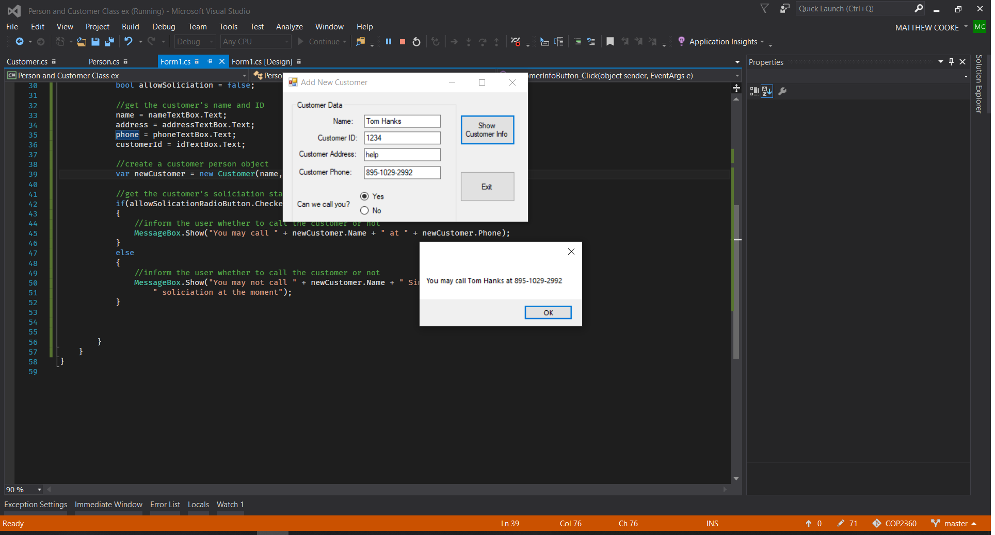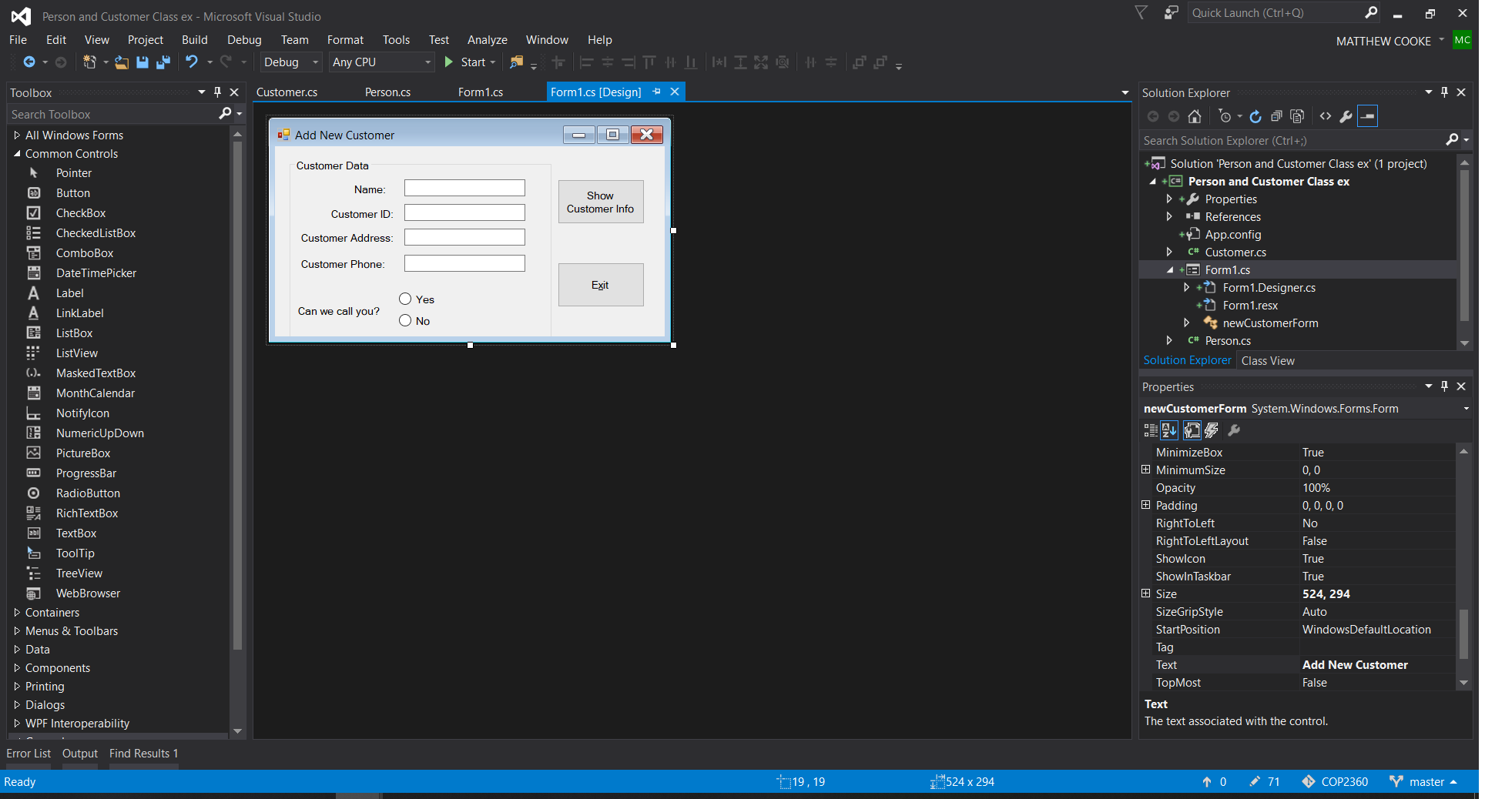using System;

using System.Collections.Generic;

using System.ComponentModel;

using System.Data;

using System.Drawing;

using System.Linq;

using System.Text;

using System.Threading.Tasks;

using System.Windows.Forms;

namespace Person_and_Customer_Class_ex

{

public partial class newCustomerForm : Form

{

public newCustomerForm()

{

InitializeComponent();

}

private void exitButton_Click(object sender, EventArgs e)

{

this.Close();

}

private void customerInfoButton_Click(object sender, EventArgs e)

{

//variables to hold input

string name, phone, address, customerId;

bool allowSoliciation = false;

//get the customer's name and ID

name = nameTextBox.Text;

address = addressTextBox.Text;

phone = phoneTextBox.Text;

customerId = idTextBox.Text;

//create a customer person object

var newCustomer = new Customer(name, address, customerId, phone, allowSoliciation);

//get the customer's soliciation status

if(allowSolicationRadioButton.Checked)

{

//inform the user whether to call the customer or not

MessageBox.Show("You may call " + newCustomer.Name + " at " + newCustomer.Phone);

}

else

{

//inform the user whether to call the customer or not

MessageBox.Show("You may not call " + newCustomer.Name + " Since they are not allowing" +

" soliciation at the moment");

}

}

}

}